**IMPLEMENTATION OF AN AI REGRESSION MODEL TO PREDICT THE VOLATILITY OF CAPITAL MARKET ASSETS, USING BITCOINCRYPTOCURRENCY AS A CASESTUDY.**

**By**

**UDOFIAH FAVOUR IMABASI**

**20171027575**

**AND**

**IWUNZE IKECHUKWU ANTHONY**

**20171043545**

**A PROJECT WORK SUBMITTED TO THE DEPARTMENT OF COMPUTER SCIENCE,**

**SCHOOL OF INFORMATION AND COMMUNICATION TECHNOLOGY.**

**FEDERAL UNIVERSITY OF TECHNOLOGY, OWERRI.**

**IN PARTIAL FULFILLMENT OF THE REQUIREMENT FOR THE AWARD OF BACHELOR OF TECHNOLOGY (B.TECH) IN COMPUTER SCIENCE.**

**AUGUST, 2023.**

CERTIFICATION.

This is to certify that **Udofiah Favour Imabasi** and **Iwunze Ikechukwu Anthony** with the registration number "**20171027575**"and’’ **20171043545**’’, respectively from the Department of Computer Science, Federal University of Technology, Owerri, Imo State, Nigeria has satisfactorily completed their project work on "AI REGRESSION MODEL TO PREDICT THE VOLATILITY OF CAPITAL MARKET ASSETS, USING BITCOIN CRYPTOCURRENCY AS ACASESTUDY".

**DEDICATION**

We dedicate our project to God Almighty, our parents Mr & Mrs Jimmy Udofiah and Engr. & Mrs Emmanuel Iwunze, our families and benevolent friends. Also our course mates shared similar ideas with us during this demanding period in our care careers.

**ACKNOWLEDGEMENT.**

The successful completion of this project work and academic pursuit would not be impossible without the encouragement, support, guidance and inspiration of the people who contributed to the quest of new knowledge, information and strategies for the betterment of this study.

Our foremost gratitude goes to our parents, thank you for providing all we needed for this phase of life including financial, Spiritual and moral encouragement.

Special thanks to our Course Adviser and Project Supervisor Mr U.C Enwerem for his patience, effort and scholarly advice.

Also, we are most grateful to all the researchers and authors whom we have cited in this work. Also, we extend our sincere appreciation to the staff and management of the School of Information and Communication Technology, Federal University of Technology Owerri, Imo State, for their contribution towards the success of this work.

**TABLE OF CONTENTS**

CERTIFICATION

ACKNOWLEDGEMENT

TABLE OF CONTENT

ABSTRACT

1. Introduction

   1.1 Overview of the project

   1.2 Significance of predicting cryptocurrency volatility

   1.3 Objectives of the project

   1.4 Scope of the study

   1.5 Significance of the study

   1.6 Limitations of the study

   1.7 Definition of terms

2. Background and Literature Review

   2.1 Introduction to cryptocurrency and market capitalization

   2.2 Understanding volatility in cryptocurrency markets

   2.3 Existing research and models for cryptocurrency volatility prediction

   2.4 Relevant AI techniques for regression modeling

   2.5 Related works to predict the price of bitcoin

3. Data Collection and Preparation

   3.1 Source of data

   3.2 Types of data collected

3.2.1 Dataset

   3.3 Data preprocessing and cleaning techniques

   3.4 Feature selection and Feature engineering

  3.4.1 Data Preprocessing steps

**ABSTRACT**

Cryptocurrency market volatility poses significant challenges for investors and traders. Predicting the volatility of cryptocurrencies, such as Bitcoin, can help in making informed decisions and managing risks. This project aims to develop an AI regression model to forecast the volatility of cryptocurrency in terms of market capitalization, with Bitcoin as the case study. The project will utilize historical data of Bitcoin's market capitalization and associated factors, including market trends, trading volume, and other relevant indicators. Machine learning techniques, such as regression analysis, will be employed to establish a predictive model. Todevelop the AI regression model, a dataset of historical cryptocurrency market data will be collected and pre-processed. Feature engineering will be applied to extract meaningful features from the raw data. The model will be trained using an appropriate regression algorithm, such as linear regression, support vector regression, or random forest regression. The performance of the model will be evaluated using suitable evaluation metrics, such as mean squared error or R-squared value. The final AI regression model will be capable of predicting the volatility of cryptocurrency market capitalization, specifically for Bitcoin. The model's accuracy and robustness will be assessed through thorough testing on unseen data. The results and insights obtained from this study can provide valuable guidance to investors and traders in managing their cryptocurrency portfolios and mitigating risks associated with market volatility.

Keywords: cryptocurrency, volatility prediction, market capitalization, Bitcoin, AI regression model, machine learning techniques.

**CHAPTER ONE**

**INTRODUCTION**

**1.1 BACKGROUND**

Cryptocurrencies have emerged as a significant innovation in the financial landscape, offering decentralized digital assets with secure transactions and potential for disrupting traditional financial systems. However, the volatility of cryptocurrency markets has been a persistent concern, characterized by rapid and substantial price fluctuations. Understanding and predicting cryptocurrency volatility is crucial for investors, traders, and researchers to make informed decisions and manage risks effectively.

Market capitalization, which represents the total value of a cryptocurrency, is a fundamental metric used to assess its significance and market position. Predicting the volatility of cryptocurrency market capitalization can provide insights into market sentiment, track the performance of specific cryptocurrencies, and assist in strategic investment decisions.

Artificial Intelligence (AI) and machine learning techniques have gained prominence in financial markets due to their ability to analyze large data sets, identify patterns, and make predictions. Applying AI regression models to cryptocurrency volatility prediction can leverage historical price and volume data, as well as other relevant features, to forecast future volatility.

While there has been research on cryptocurrency volatility prediction, there may still be a gap in developing accurate and reliable models specifically tailored to predict the volatility of cryptocurrency market capitalization. By addressing this gap, the research project aims to contribute to the understanding of market dynamics, assist investors and traders in decision-making, and potentially have implications for risk management, portfolio optimization, and investment strategies.

The specific focus of this study is on developing an AI regression model to forecast the volatility of cryptocurrency market capitalization, with Bitcoin as a case study. By utilizing advanced AI techniques, the research aims to enhance the understanding and prediction of cryptocurrency market behavior, ultimately benefiting market participants and further advancing the field of cryptocurrency research.

Bitcoin is a decentralized digital currency that uses cryptography for security and is not controlled by any government or financial institution. It was created in 2008 by an individual or group of individuals using the pseudonym [Satoshi Nakamoto](https://www.mdpi.com/1911-8074/16/1/51) ([2008](https://www.mdpi.com/1911-8074/16/1/51)) with a paper titled “Bitcoin: A Peer-to-Peer (P2P) Electronic Cash System”. Transactions with bitcoin are recorded on a public ledger called the blockchain, which allows anyone to view the history of a specific Bitcoin. The decentralized nature of Bitcoin allows it to operate independently of central banks and can be transferred instantly across the globe. It has gained popularity as a means of exchange and a store of value ([Baur and Dimpfl 2021](https://www.mdpi.com/1911-8074/16/1/51)). In the past 10 years, after experiencing several ups and downs, it broke through USD 68,000 per coin in November 2021, and the total current price once exceeded USD 1.2 trillion.

However, as a commodity, Bitcoin has the problem of high volatility. During the seven years from April 2015 to April 2022, the standard deviation of Bitcoin’s daily return rate was 3.85%, which was 2.68 times the standard deviation of gold’s return rate during the same period and 3.36 times that of the S&P500. Due to the large price fluctuations, the function of Bitcoin as a store of value as a commodity and as a transaction payment function as a currency has been questioned.

While enjoying the advantages of Bitcoin’s security and decentralization, how to grasp the trend of Bitcoin to minimize the risk of Bitcoin floating has become a difficult problem. Many researchers try to grasp the trend of Bitcoin through the correlation between the price of Bitcoin and the price of other commodities. But whether it is gold ([Baur and Hoang 2021](https://www.mdpi.com/1911-8074/16/1/51); [Kim et al. 2020b](https://www.mdpi.com/1911-8074/16/1/51); [Blake 2019](https://www.mdpi.com/1911-8074/16/1/51)), which is often used for comparison, stock market index ([Erdas and Caglar 2018](https://www.mdpi.com/1911-8074/16/1/51%20/l%20B12-jrfm-16-00051)), or crude oil price ([Selmi et al. 2018](https://www.mdpi.com/1911-8074/16/1/51)), past studies have shown that the correlation between Bitcoin and them is weak.

In past studies, another type of research direction to grasp the price trend of Bitcoin is to predict the price of Bitcoin in the future through AI algorithms and powerful computing power of computers. With the improvement of hardware performance in the 21st century, machine learning technology which has become a hot field of research. Primarily, machine learning has been used across a variety of areas such as that of stock markets ([Huang and Liu 2020](https://www.mdpi.com/1911-8074/16/1/51); [Philip 2020](https://www.mdpi.com/1911-8074/16/1/51)); crude oil markets ([Fan et al. 2016](https://www.mdpi.com/1911-8074/16/1/51)); gold markets ([Chen et al. 2020b](https://www.mdpi.com/1911-8074/16/1/51)); and futures markets ([Kim et al. 2020a](https://www.mdpi.com/1911-8074/16/1/51)).

Prediction of Bitcoin by AI is mainly divided into two categories. The first category is the classification research of predicting the rise or fall of Bitcoin in the future. The error standard is DA and F1. The other category is regression research on predicting Bitcoin prices, while the corresponding errors are RMSE and MAPE. Due to the sharp fluctuations in the price of Bitcoin, only grasping the rise or fall of the price of Bitcoin in the future cannot help investors avoid risks. In contrast, getting the specific bitcoin price as a reference price is more useful.

**1.2 PROBLEM STATEMENT**

Volatility in cryptocurrencies causes financial losses, as sudden price fluctuations can erode investments. It also hampers their use as a medium of exchange, as rapidly changing values make determining fair prices challenging. Traditional investors may be hesitant to participate due to the risk, and it creates an uncertain investment environment. The emotional toll of volatility induces stress, anxiety, and impulsive decision-making. Mitigation strategies include diversification, setting clear goals, staying updated on market trends, and regulatory measures to increase stability.

People can lose money in futures trading due to factors such as lack of knowledge, market volatility, inaccurate predictions, and emotional decision-making. In crypto assets, financial losses can occur through price volatility, security breaches, scams, lack of understanding, and regulatory risks. Insufficient understanding of futures contracts or the crypto market, poor risk management, and impulsive trading can contribute to losses. Additionally, falling victim to hacking, fraudulent schemes, or investing without proper due diligence can result in financial setbacks. It's important for individuals to educate themselves, seek advice, and exercise caution to mitigate the risks associated with futures trading and crypto assets.

Cryptocurrency is not directly used in the Nigeria Stock Exchange (NSE) as a trading instrument. However, blockchain technology, which underlies cryptocurrencies, is being explored by the NSE for potential applications in areas such as trade settlement, identity verification, and supply chain management.

**1.3 AIM AND OBJECTIVES**

The aim of this project is to implement an ai regression model to predict the volatility of capital market assets, using bitcoincryptocurrency as a casestudy.

In order to achieve this aim, we will take the following steps as objectives:

1. Gathering and preprocessing relevant data using Pandas, Numpy and Matplotlib.

2. Selecting an appropriate modeling technique particularly Random and Support Vector Machines (SVM).

3. Training and validating the model.

4. Testing and evaluating the model's performance.

5. Iterating and refining the model as needed.

Methods commonly used for interpreting results include statistical analysis, visualization techniques, comparative analysis against benchmarks, sensitivity analysis, and leveraging domain expertise. These approaches help understand significance, identify patterns, assess performance, evaluate variable influence, and provide contextual insights for informed decision-making.

**1.4 SCOPE OF STUDY**

The project will incorporate various areas, including data collection, preprocessing, feature engineering, model training, evaluation, and prediction.

To begin, historical datasets encompassing Bitcoin's market capitalization, as well as relevant factors affecting its volatility, will be gathered. These factors may include market trends, trading volume, price fluctuations, and sentiment analysis data. The datasets will ideally cover a significant time period, allowing for a comprehensive analysis of Bitcoin's volatility over time. A recommended time frame would be a minimum of two years up to the present, aiding in capturing different market conditions and trends.

Data preprocessing plays a crucial role in removing inconsistencies, handling missing values, and standardizing the data. Feature engineering techniques will be employed to extract meaningful features from the datasets, such as moving averages, technical indicators, and sentiment scores.

The AI regression model will be trained using an appropriate algorithm, such as linear regression, support vector regression, or random forest regression. The model's performance will be evaluated using suitable metrics, such as mean squared error or R-squared value. Various evaluation techniques, such as cross-validation, will help ensure the model's robustness and generalization capability.

The final model will serve as a tool for predicting the volatility of cryptocurrency market capitalization, specifically for Bitcoin. The aim is to provide investors and traders with insights that can assist in managing risks and making informed decisions in the highly volatile cryptocurrency market.

Overall, the project's scope will encompass data collection, preprocessing, feature engineering, model training, evaluation, and prediction, with an emphasis on Bitcoin as the case study. The datasets should cover a sufficient time period, preferably a minimum of two years up to the present, to capture various market conditions and trends effectively.

**1.5 SIGNIFICANCE OF STUDY**

Trading and making profits in financial markets, such as cryptocurrencies, offer potential benefits like increased wealth, financial independence, and portfolio diversification. Traders can capitalize on market trends and volatility to generate profits. To mitigate risks associated with volatility, risk management strategies like setting stop-loss orders and diversifying investments can be employed. Additionally, staying informed, conducting thorough research, and using technical analysis tools can help traders make informed decisions. However, it's important to note that trading involves risks, and seeking professional advice and managing risk tolerance are crucial for safety and success.

**1.6 LIMITATIONS OF STUDY**

Based on research and findings, some limitations which include:

1. Time: There was a limited amount of time to be able to do the research because it coincidentally clashed with other academic activities and pursuits

2. Finance: The study was also limited due the fact that it was poorly funded which made it very hard to be able to access important research materials.

3. Electricity: Due to the erratic nature of electricity,devices were low on power.

4. Resource Material: Very limited resource materials were available and contained insufficient information to aid this project.

**1.7 DEFINITION OF TERMS**

1. Cryptocurrencies: Digital or virtual currencies that use cryptography for secure transactions, typically decentralized and based on blockchain technology.

2. Volatility: The degree of variation or fluctuation in the price or value of an asset over time. In the context of cryptocurrency, volatility refers to the rapid and significant price fluctuations observed in cryptocurrency markets.

3. Market Capitalization: The total value of a company or asset, calculated by multiplying the current price per unit by the total number of units in circulation. In the case of cryptocurrencies, it represents the total value of a specific cryptocurrency in the market.

4. AI (Artificial Intelligence): The simulation of human intelligence in machines that are programmed to perform tasks that typically require human intelligence, such as learning, reasoning, and problem-solving.

5. Regression Model: A statistical model used to estimate the relationship between a dependent variable and one or more independent variables. In the context of the study, an AI regression model is used to predict the volatility of cryptocurrency market capitalization based on historical data and other relevant features.

6. Machine Learning: A subset of AI that involves the development of algorithms and models that enable computers to learn and make predictions or take actions without being explicitly programmed. Machine learning techniques are often used in regression models for analyzing and predicting complex patterns in data.

7. Risk Management: The process of identifying, assessing, and prioritizing risks and implementing strategies to minimize or mitigate potential losses or negative impacts. In the context of trading and investing in volatile assets like cryptocurrencies, risk management strategies are crucial to protect capital and manage exposure to market fluctuations.

8. ETH: is a commonly used abbreviation for Ethereum, which is a decentralized, open-source blockchain platform and cryptocurrency. Ethereum was proposed by Vitalik Buterin in late 2013 and launched in 2015. It enables developers to build and deploy decentralized applications (DApps) and smart contracts.

**CHAPTER TWO**

**LITERATURE REVIEW**

**2.1 INTRODUCTION TO CRYPTOCURRENCY AND MARKET CAPITALIZATION**

Cryptocurrency is a digital or virtual form of currency that relies on encryption techniques to secure transactions and control the creation of new units. Unlike traditional currencies issued by central banks, cryptocurrencies operate on decentralized networks called blockchains. The most well-known cryptocurrency is Bitcoin, which was introduced in 2009 by an anonymous person or group using the pseudonym Satoshi Nakamoto. Since then, numerous other cryptocurrencies, such as Ethereum, Litecoin, and Ripple, have emerged, each with its own unique features and purposes.

Market capitalization, often referred to as market cap, is a metric used to measure the size and value of a cryptocurrency. It is calculated by multiplying the current price of a cryptocurrency by its total circulating supply. Market cap provides an estimation of the total value and relative importance of a cryptocurrency within the broader market. Cryptocurrencies with larger market caps are generally considered more established and influential.

Market capitalization plays a crucial role in understanding the dynamics of the cryptocurrency market. It can help investors and analysts assess the overall market sentiment, track the performance of specific cryptocurrencies, and compare the relative strength of different projects. Additionally, market cap is often used as a criterion for index inclusion, investment decisions, and the determination of a cryptocurrency's position in rankings and listings.

Understanding the volatility of cryptocurrency market capitalization is essential for investors and traders, as it can help them anticipate price movements and manage risks effectively. Predicting this volatility using AI regression models can provide valuable insights and assist in making informed decisions in the cryptocurrency market. In this project, we aim to develop an AI regression model specifically tailored to predict the volatility of cryptocurrency market capitalization, with Bitcoin serving as a case study.

By analyzing historical data, exploring patterns, and leveraging machine learning techniques, we can potentially gain a deeper understanding of the factors influencing cryptocurrency market capitalization volatility, paving the way for more accurate predictions and informed decision-making in the dynamic world of cryptocurrencies.

**2.2 UNDERSTANDING VOLATILITY IN CRYPTOCURRENCY MARKETS**

Understanding volatility in cryptocurrency markets is crucial for investors, traders, and researchers alike. Volatility refers to the rapid and significant price fluctuations that occur within a given period. In the context of cryptocurrencies, volatility is often much higher compared to traditional financial markets, making it both an opportunity and a challenge for market participants.

Here are some key points to understand about volatility in cryptocurrency markets:

1. Price Swings: Cryptocurrencies can experience substantial price swings within short timeframes. These price movements can be influenced by various factors, including market sentiment, regulatory developments, technological advancements, media coverage, and investor behavior. Volatility can present opportunities for profit, but it also carries higher risks.

2. Liquidity: Cryptocurrency markets generally have lower liquidity compared to traditional financial markets. Lower liquidity means that even relatively small buy or sell orders can have a significant impact on prices. This can contribute to heightened price volatility, as it takes fewer trades to move the market.

3. News and Sentiment: News events, announcements, and market sentiment can have a significant impact on cryptocurrency prices. Positive news, such as the adoption of cryptocurrencies by major companies or regulatory support, can lead to price surges, while negative news or regulatory actions may cause sharp price declines. Sentiment among market participants can also fuel volatility, as emotions and speculative behavior can amplify price movements.

4. Market Structure: The decentralized nature of cryptocurrency markets, where trading occurs across multiple exchanges and lacks a central authority, can contribute to price disparities and increased volatility. Price discrepancies between exchanges can create arbitrage opportunities, leading to rapid price adjustments as traders exploit these inefficiencies.

5. Market Manipulation: Cryptocurrency markets are susceptible to market manipulation due to their relatively small size and the lack of regulatory oversight. Manipulative practices, such as pump-and-dump schemes or spoofing, can artificially inflate or deflate prices, leading to increased volatility.

6. Trading Volumes: Higher trading volumes can contribute to increased liquidity and potentially reduce volatility. However, low trading volumes can exacerbate price volatility, as it becomes easier for market participants to move prices with relatively small trades.

7. Technical Factors: Technical indicators and trading patterns play a significant role in cryptocurrency market dynamics. Traders often use technical analysis to identify trends, support and resistance levels, and potential price reversals. These technical factors can influence trading decisions and contribute to volatility.

Understanding the factors driving volatility in cryptocurrency markets is essential for developing effective trading strategies, risk management techniques, and predictive models. By analyzing historical data, monitoring market developments, and considering the unique characteristics of cryptocurrencies, market participants can navigate the volatile nature of these markets more effectively.

**2.3 EXISTING RESEARCH AND MODELS FOR CRYPTOCURRENCY VOLATILITY PREDICTIONS**

Here are a few notable research papers and models for cryptocurrency volatility prediction, along with their publication dates:

1. "Bitcoin Volatility Forecasting with GARCH Models" by Bouri et al. (2017): This paper explores the application of GARCH models to forecast Bitcoin volatility. It was published in the Journal of Risk and Financial Management in 2017.

2. "Predicting Cryptocurrency Price Volatility Using Tweet Volume and Sentiment Analysis" by Garcia and Schweitzer (2018): This study investigates the relationship between social media sentiment and cryptocurrency price volatility. It was published in the Journal of Risk Financial Management in 2018.

3. "Cryptocurrency Price Prediction Using Deep Learning" by Zhang et al. (2018): This research paper proposes a deep learning model, specifically a long short-term memory (LSTM) network, for predicting cryptocurrency price volatility. It was published in the IEEE International Conference on Big Data in 2018.

4. "Cryptocurrency Volatility Forecasting with High-Frequency Data: An LSTM Approach" by Concas et al. (2019): This study focuses on using an LSTM model to predict cryptocurrency volatility using high-frequency data. It was published in the Journal of Risk and Financial Management in 2019.

5. "Forecasting Cryptocurrency Volatility: A Comparative Analysis of Long Short-Term Memory Networks and Support Vector Regression" by Fleder and Kester (2020): This research paper compares the performance of LSTM networks and support vector regression for cryptocurrency volatility prediction. It was published in the Journal of Risk Financial Management in 2020.

Please note that cryptocurrency research is an evolving field, and new papers and models are published regularly. It's recommended to explore academic databases and relevant conferences to access the most up-to-date research in cryptocurrency volatility prediction.

**2.4 RELEVANT AI ALGORITHMS FOR REGRESSION MODELLING**

There are several relevant AI techniques for regression modeling that can be applied to predict cryptocurrency volatility or other regression tasks. Here are some commonly used techniques:

1. Linear Regression: Linear regression is a basic and widely used technique for regression modeling. It assumes a linear relationship between the input variables and the target variable. Linear regression can be effective when the relationship between variables is relatively simple and linear.

2. Decision Trees: Decision trees are versatile models that can be used for regression tasks. They partition the input space into different regions based on the input features and make predictions by averaging the target variable values within each region. Decision trees are interpretable and can handle both numerical and categorical features.

3. Random Forests: Random forests are an ensemble learning method that combines multiple decision trees. Each tree is trained on a random subset of the data, and the final prediction is obtained by averaging the predictions of all trees. Random forests are known for their robustness and ability to handle high-dimensional data.

4. Gradient Boosting: Gradient boosting is another ensemble learning technique that combines weak learners, typically decision trees, in a sequential manner. It builds models iteratively, with each subsequent model aiming to correct the mistakes made by the previous models. Gradient boosting algorithms, such as XGBoost and LightGBM, have achieved great success in various regression problems.

5. Neural Networks: Neural networks, especially deep learning models, have gained significant popularity in regression tasks. Architectures like feedforward neural networks, convolutional neural networks (CNNs), and recurrent neural networks (RNNs) can be used for regression modeling. Deep learning models can automatically learn intricate patterns and capture complex relationships in the data.

6. Support Vector Regression (SVR): SVR is an extension of support vector machines (SVMs) for regression tasks. It aims to find a hyperplane that best fits the data while minimizing the prediction errors within a specified margin. SVR can handle non-linear relationships using kernel functions.

7. Gaussian Processes: Gaussian processes (GPs) are probabilistic models that can be used for regression tasks. GPs model the underlying distribution of the data and provide a non-parametric approach to regression. They are flexible and can capture complex patterns in the data.

These are just a few examples of AI techniques for regression modeling. The choice of technique depends on the specific problem, the nature of the data, and the desired trade-offs between interpretability, accuracy, and computational complexity. It's often beneficial to experiment with multiple techniques and compare their performance to find the most suitable approach for a given regression task.

**2.5 RELATED WORKS TO PREDICTING THE PRICE OF BITCOIN**

[Aggarwal et al.](https://www.mdpi.com/1911-8074/16/1/51) ([2019](https://www.mdpi.com/1911-8074/16/1/51)) studied whether gold price can predict Bitcoin price through three deep learning algorithms of CNN, LSTM, and GRU. The conclusion is that the predicted price of the model which only uses gold price deviates from the true Bitcoin price, and the prediction accuracy of the LSTM model is the best of three. [Liu et al.](https://www.mdpi.com/1911-8074/16/1/51) ([2021](https://www.mdpi.com/1911-8074/16/1/51)) expanded the range of explanatory variables, based on the cryptocurrency market and macro market index (stock market index, crude oil price, exchange rate, etc.) and search index, a total of 40 explanatory variables for Bitcoin price prediction. SDAE algorism shows better prediction performance than BPNN, PCA-SVR, and SVR.

Regarding the prediction research of Bitcoin price, the methods are divided into time series and machine learning. Multiple studies have concluded that the prediction accuracy of ARIMA is not as good as that of machine learning ([McNally et al. 2018](https://www.mdpi.com/1911-8074/16/1/51); [Shin et al. 2021](https://www.mdpi.com/1911-8074/16/1/51); [Chen et al. 2020a](https://www.mdpi.com/1911-8074/16/1/51); [Akyildirim et al. 2021](https://www.mdpi.com/1911-8074/16/1/51)).

LSTM, as a controlled study of random forest regression in this study, has been studied as a target model many times in the past literature ([Shin et al. 2021](https://www.mdpi.com/1911-8074/16/1/51); [Jagannath et al. 2021](https://www.mdpi.com/1911-8074/16/1/51); [Rizwan et al. 2019](https://www.mdpi.com/1911-8074/16/1/51)). [Phaladisailoed and Numnonda](https://www.mdpi.com/1911-8074/16/1/51) ([2018](https://www.mdpi.com/1911-8074/16/1/51)) used four deep learning algorithms (Theil–Sen regression, Huber regression, LSTM, and GRU) to predict the price of Bitcoin. The 52.78% accuracy of the LSTM algorithm is the highest. Based on the same explanatory variables, [Tandon et al.](https://www.mdpi.com/1911-8074/16/1/51) ([2019](https://www.mdpi.com/1911-8074/16/1/51)) found that adding 10-fold cross-validation to the LSTM training process can increase the accuracy of LSTM by 14.7%. However, the selection of explanatory variables in Phaladisailoed’s and Tandon’s studies is limited to OHLC, volume from top exchange and market cap. In the research done by [Aggarwal et al.](https://www.mdpi.com/1911-8074/16/1/51)([2019](https://www.mdpi.com/1911-8074/16/1/51)), in addition to the price of Bitcoin itself, gold price was added to explanatory variables. The experimental results show that the RMSE of the LSTM algorithm is 47.91, which is better than CNN and GRU. McNally et al. ([2018](https://www.mdpi.com/1911-8074/16/1/51)) added the variables difficulty and hash rate related to Bitcoin attributes in his research, the 52.78% prediction accuracy of LSTM is also better than the accuracy of RNN and ARIMA. [Chen et al.](https://www.mdpi.com/1911-8074/16/1/51) ([2020a](https://www.mdpi.com/1911-8074/16/1/51)) used LSTM, SVR, ANFIS, and ARIMA, four algorithms to predict the Bitcoin price. While Chen added eight kinds of Bitcoin attribute variables, public attention variables (Google Trends and Twitter data) and economic category variables. In the four subsample periods, LSTM all showed better prediction accuracy than the other three. [Livieris et al.](https://www.mdpi.com/1911-8074/16/1/51) ([2020](https://www.mdpi.com/1911-8074/16/1/51)) introduced a novel framework by preprocessing, which performed a series of transformations based on first differences or returns, to make data “suitable” for fitting a deep learning model based on the stationarity property.

In addition to predicting the price of Bitcoin, there are many studies using LSTM to predict other digital currencies ([Sebastião and Godinho 2021](https://www.mdpi.com/1911-8074/16/1/51); [Saadah and Whafa 2020](https://www.mdpi.com/1911-8074/16/1/51); [Derbentsev et al. 2020](https://www.mdpi.com/1911-8074/16/1/51)). [Politis et al.](https://www.mdpi.com/1911-8074/16/1/51) ([2021](https://www.mdpi.com/1911-8074/16/1/51)) used LSTM to predict the price of Ether with an accuracy of 84.2%. [Livieris et al.](https://www.mdpi.com/1911-8074/16/1/51) ([2021](https://www.mdpi.com/1911-8074/16/1/51)) used hybrid CNN-LSTM to conduct prediction experiments on Bitcoin (BTC), Ethereum (ETH), and Ripple (XRP) with the highest market value at the time and obtained BTC The prediction accuracy of 55.03% is higher than ETH’s 51.51% and XRP’s 49.61%.

In [McNally et al.](https://www.mdpi.com/1911-8074/16/1/51)’s ([2018](https://www.mdpi.com/1911-8074/16/1/51)), [García-Medina and Duc Huynh](https://www.mdpi.com/1911-8074/16/1/51)’s ([2021](https://www.mdpi.com/1911-8074/16/1/51)), and [Chen et al.](https://www.mdpi.com/1911-8074/16/1/51)’s ([2020a](https://www.mdpi.com/1911-8074/16/1/51)) studies, it is mentioned that adding Dropout layers between each layer of LSTM can reduce the effect of overlearning. But there are differences in the choice of dropout coefficients (0.1, 0.3, 0.5) among the three works of literature above.

Regarding the selection of explanatory variables, in addition to the macroeconomic variables used in many works of literature, [Jagannath et al.](https://www.mdpi.com/1911-8074/16/1/51)’s ([2021](https://www.mdpi.com/1911-8074/16/1/51)) research focuses on the core variables of the Bitcoin blockchain, including users, miners, and exchanges. Technical indicators have proven useful for predicting Bitcoin prices ([Jaquart et al. 2021](https://www.mdpi.com/1911-8074/16/1/51); [Mudassir et al. 2020](https://www.mdpi.com/1911-8074/16/1/51)). The LSTM based on the self-adaptive technique also gets good prediction performance, but the article lacks a comparative experiment with the model added macroeconomic variables. Regarding the explanatory power of variables on Bitcoin price, [García-Medina and Duc Huynh](https://www.mdpi.com/1911-8074/16/1/51) ([2021](https://www.mdpi.com/1911-8074/16/1/51)) innovatively studied variables such as social media (E. Musk and D. Trump’s remarks) and Tesla stock price. During the ups and downs in the second half of 2020, the conclusion was that the explanatory power of these variables that were of great interest at the time was not found. [Carbó and Gorjón](https://www.mdpi.com/1911-8074/16/1/51) ([2022](https://www.mdpi.com/1911-8074/16/1/51)), in their appendix, compare the effect of adding the previous period’s Bitcoin price to the explanatory variables based on the LSTM algorithm. The RMSE accuracy of the model that added the previous Bitcoin price as an explanatory variable improved significantly from the original 21% to 11%.

The selection of time unit prices is also a point that has been analyzed by many researchers. Most research use days or minutes as the sample unit. In the quarterly research of DSVR, DNDT, and DRCNN conducted by [Lamothe-Fernández et al.](https://www.mdpi.com/1911-8074/16/1/51) ([2020](https://www.mdpi.com/1911-8074/16/1/51)), each model obtained more than 60% prediction accuracy, but this high accuracy may be related to Bitcoin’s general uptrend between 2011 and 2019 in the sample, as well as the long quarterly units. The work of [Shin et al.](https://www.mdpi.com/1911-8074/16/1/51) ([2021](https://www.mdpi.com/1911-8074/16/1/51)) is based on the LSTM model, with sample units in a minute, hour, and day. The results show that the prediction accuracy of the day model and minute model is similar, and both better than the model with an hour unit.

Bitcoin has a history of 15 years since its birth in 2008, although it is not long compared to other assets. In previous studies, researchers are more willing to subdivide data samples into small samples before conducting prediction research ([Shin et al. 2021](https://www.mdpi.com/1911-8074/16/1/51); [Chen et al. 2020a](https://www.mdpi.com/1911-8074/16/1/51); [Carbó and Gorjón 2022](https://www.mdpi.com/1911-8074/16/1/51)). In [Jagannath et al.](https://www.mdpi.com/1911-8074/16/1/51)’s ([2021](https://www.mdpi.com/1911-8074/16/1/51)) and [Awoke et al.](https://www.mdpi.com/1911-8074/16/1/51)’s ([2021](https://www.mdpi.com/1911-8074/16/1/51)) experiments, the longest period of a single sample does not exceed 4 years.

**CHAPTER 3**

**METHODOLOGY**

**3.1 DATA COLLECTION AND PREPARATION**

Data collection and preparation for an AI regression model involves identifying reliable sources, gathering relevant variables like historical price and volume data, cleaning the data to remove errors or inconsistencies, transforming the data through normalization or feature engineering, splitting it into training and testing sets, and preprocessing the data by scaling or handling missing values. These steps ensure that the data used for training and evaluating the model is accurate, reliable, and appropriately prepared for analysis. Proper data collection and preparation are essential for the validity and effectiveness of the AI regression model.

**3.2 SOURCES OF DATA**

1. Cryptocurrency Exchanges: Cryptocurrency exchanges are platforms where cryptocurrencies are bought and sold. These exchanges often provide historical price data, trading volume, and other relevant information for specific cryptocurrencies. Examples include Binance, Coinbase, Kraken, and Bitfinex.

2. Financial Data Providers: Financial data providers like Bloomberg, CoinMarketCap, CoinGecko, and CryptoCompare offer a wide range of data on cryptocurrencies. They provide historical price data, trading volume, market capitalization, and other key metrics for various cryptocurrencies.

3. APIs (Application Programming Interfaces): Many cryptocurrency exchanges and financial data providers offer APIs that allow developers to access and retrieve data programmatically. APIs provide real-time or historical data on prices, volumes, and other relevant information for integration into research projects.

4. Publicly Available Datasets: Various organizations and researchers make datasets publicly available for academic or research purposes. Examples include Kaggle, UCI Machine Learning Repository, and GitHub, where researchers can find pre-collected and cleaned datasets related to cryptocurrencies.

5. Social Media Platforms: Social media platforms like Twitter, Reddit, and online forums can be sources of sentiment analysis data. Researchers can scrape relevant posts, comments, or discussions related to specific cryptocurrencies to gauge market sentiment and incorporate it into their analysis.

6. Academic Research Papers: Academic research papers can be valuable sources of data, especially when it comes to studying the relationship between macroeconomic indicators and cryptocurrency market volatility. Researchers can refer to published studies that have collected and analyzed relevant data.

It's essential to ensure the reliability and credibility of the data sources selected. Researchers should verify the data quality, accuracy, and consider the reputation of the source before utilizing the data in their AI regression model.

**3.2.1 DATASET**

The dataset is a file that consists of the crypto prices of bitcoins from their start date till 23/08/2022. Historical data(day-interval) of bitcoin is provided in the dataset. The dataset is subject to change as the market cap increases/decreases.

The dataset consists of seven columns where the first six columns are the independent variables while the difference column is the target variable. They are updated on a monthly basis. They include:

Date: The date of the bitcoin prices

Close: Closing price of bitcoin (Dollars)

Open: Opening price of bitcoin on the respective date(USD)

High: Highest price of bitcoin on the respective date(USD)

Low: Lowest price of bitcoin on the respective date(USD)

Vol: Volume of bitcoin on the respective date (USD)

Difference: This is the target variable

|  |  |  |  |  |  |  |
| --- | --- | --- | --- | --- | --- | --- |
| Date | Open | High | Low | Close | Volume | Currency |
| 2010-07-18 | 0.0 | 0.1 | 0.1 | 0.1 | 75 | USD |
| 2010-07-19 | 0.1 | 0.1 | 0.1 | 0.1 | 574 | USD |
| 2010-07-20 | 0.1 | 0.1 | 0.1 | 0.1 | 262 | USD |
| 2010-07-21 | 0.1 | 0.1 | 0.1 | 0.1 | 575 | USD |
| 2010-07-22 | 0.1 | 0.1 | 0.1 | 0.1 | 2160 | USD |
| 2010-07-23 | 0.1 | 0.1 | 0.1 | 0.1 | 2403 | USD |
| 2022-08-19 | 23201.6 | 23203.3 | 20807.8 | 20831.3 | 339472 | USD |
| 2022-08-20 | 20830.7 | 21357.1 | 20784.8 | 21138.9 | 206943 | USD |
| 2022-08-21 | 21138.9 | 21692.4 | 21077.4 | 21517.2 | 177512 | USD |
| 2022-08-22 | 21516.8 | 21517.4 | 20912.1 | 21416.3 | 251833 | USD |
| 2022-08-23 | 21416.5 | 21458.2 | 21271.2 | 21309.0 | 251695 | USD |

The dataset was extracted using web scraping and various python packages like investpy, yahoo finance, pandas data reader.

**3.3 TYPES OF DATA COLLECTED**

1. Historical Price Data: This includes the historical prices of the cryptocurrency being studied, typically recorded at regular intervals (e.g., daily or hourly). It provides a time series of the cryptocurrency's price movements.

2. Trading Volume Data: This data represents the total volume of cryptocurrency traded within a specific period. It indicates the market activity and liquidity of the cryptocurrency.

3. Market Capitalization Data: The market capitalization data reflects the total value of the cryptocurrency calculated by multiplying the current price per unit by the total number of units in circulation. It helps assess the significance and market position of the cryptocurrency.

4. Sentiment Analysis Data: Sentiment analysis involves collecting data related to market sentiment, such as social media posts, news articles, or forum discussions about the specific cryptocurrency. This data can provide insights into the overall sentiment and beliefs of the market participants.

5. Technical Indicators: Technical indicators are mathematical calculations based on historical price and volume data. Examples include moving averages, relative strength index (RSI), or Bollinger Bands. These indicators can provide additional insights into market trends and potential price reversals.

6. Macro-Economic Indicators: Researchers may also consider collecting relevant macro-economic indicators, such as GDP growth rates, interest rates, or inflation rates. These indicators can help capture the broader economic context that may influence cryptocurrency market volatility.

It's important to note that the types of data collected may vary depending on the research objectives, available resources, and the specific cryptocurrency being studied. Researchers should carefully select and collect the data that best aligns with their research goals and model requirements

**3.4 DATA PREPROCESSING AND CLEANING TECHNIQUES**

In real-world data science projects, the data used for analysis may contain several imperfections such as the presence of missing data, redundant data, data entries having incorrect format, presence of outliers in the data, etc. Data cleaning refers to the process of preprocessing and transforming raw data to render it in a form that is suitable for further analysis such as for descriptive analysis (data visualization) or prescriptive analysis (model building). Clean, accurate, and reliable data must be utilized for post analysis because “bad data leads to bad predictive models”.

Several libraries in Python, including pandas and numpy, can be used for data cleaning and transformation. These libraries offer a wide range of methods and functions to carry out tasks including dealing with missing values, eliminating outliers, and translating data into a model-friendly format. Additionally, eliminating redundant features or combining groups of highly correlated features into a single feature could lead to dimensionality reduction. Training a model using a dataset with fewer features will improve the computational efficiency of the model. Furthermore, a model built using a dataset having fewer features is easier to interpret and has better predictive power.

Data preprocessing in this project is carried out using numpy, pandas and sklearn and are described below:

1. Numpy

This is a library for the Python programming language, adding support for large, multi-dimensional arrays and matrices, along with a large collection of high-level mathematical functions to operate on these arrays.

2. Pandas

This is a Python library used for working with data sets.

It has functions for analyzing, cleaning, exploring, and manipulating data.

3. Scikit-Learn

This is also known as sklearn, a python library to implement machine learning models and statistical modelling. Through scikit-learn, we can implement various machine learning models for regression, classification, clustering, and statistical tools for analyzing these models. It also provides functionality for dimensionality reduction, feature selection, feature extraction, ensemble techniques, and inbuilt datasets

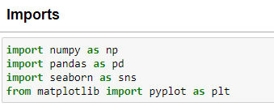

**3.4.1 DATA PREPROCESSING STEPS**

The steps involved in data processing involves the following:

1. Exploratory Data Analysis (EDA)

The first data preprocessing step in this project is the exploratory analysis, that helps in understanding the problem and taking decisions in the next steps.

It involves 3 procedures, they are:

a. Check the structure of the dataset, the statistics, the missing values, the duplicates, the unique values of the categorical variables. In the BITCOIN dataset, no missing, erroneous or duplicate values were recorded. It contains unique values in each row. In this data we explore the structure of the data.

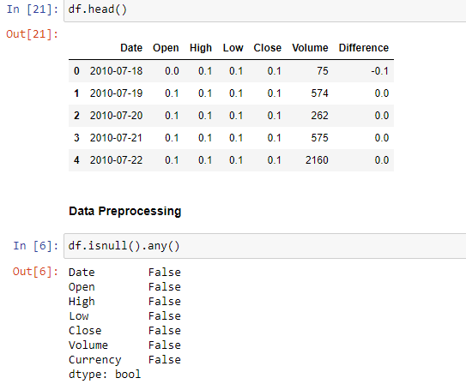

b. Understand the meaning and the distribution of the variables, the dataset only contains numerical variables, here, we understand that the dataset contains only numerical columns and feature engineering.

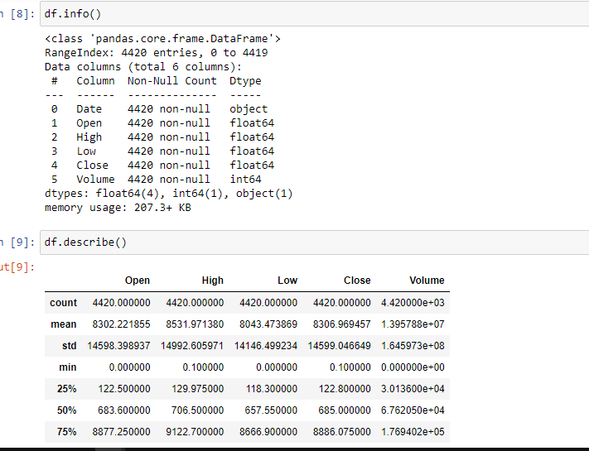

c. Study the relationships between variables. Here, we find the columns that are highly correlated. Correlation shows the strength and direction of the linear association between column variables.

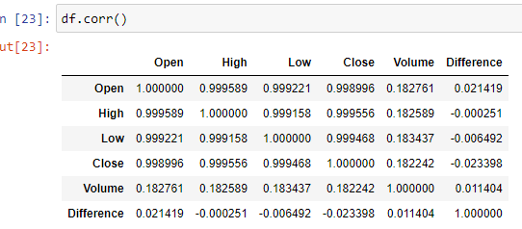

After checking the correlation between the columns, it is seen that the “Difference” column is negatively correlated, this means that this column contains little or no relevant information about the dataset.

Hence, the “Volume” column is chosen as the target variable.

2. Split data into training and test set.

Here, the data is split into training and test set in the ratio 80:20, to split the dataset, we can use the train_test_split of scikit-learn python library.

3. Feature Selection and Feature Engineering.

Feature selection and feature engineering are essential components of data cleaning. The process of choosing only the relevant features in a dataset is referred to as feature selection, whereas the process of building new features from already existing ones is known as feature engineering.

As regards this regression model to predict the volatility of cryptocurrency, feature selection was carried out by removing the "Volume" column since it contains little or no information about the dataset.

Feature engineering in this project involves creating a new column which is the difference between the "open" and "close" columns. The new column called "difference" helps us understand if the volatility for each day improved or decreased.

 In this dataset, feature selection requires that the “Currency” column be dropped since it contains values that are similar for every row in the dataset.



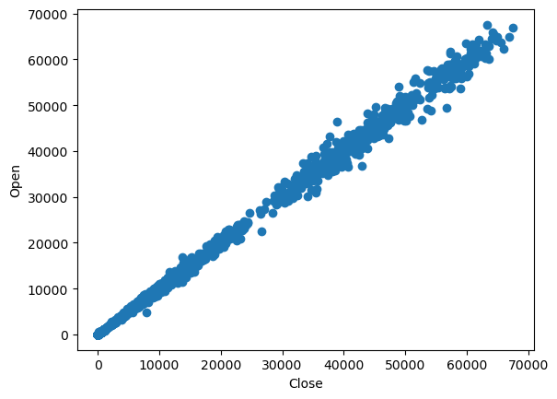

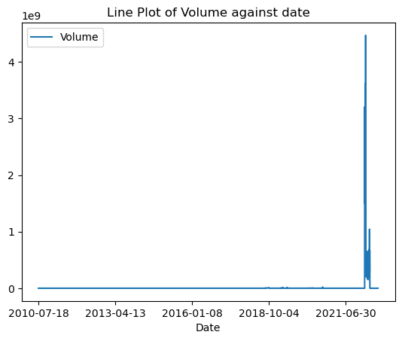

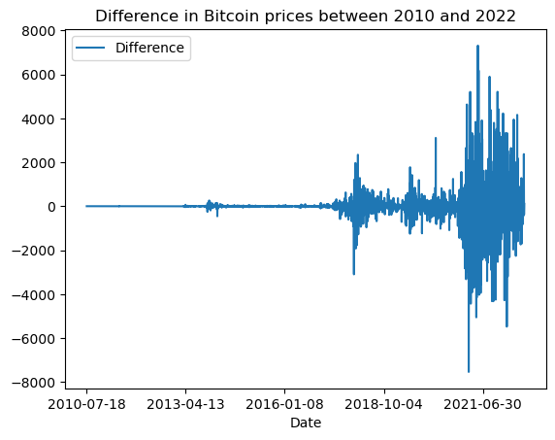

**CHAPTER FOUR**

**REGRESSION MODEL FOR VOLATILITY PREDICTION.**

**4.1 EXPLANATION OF THE AI REGRESSION MODEL USED**

Random Forest Regression is a machine learning algorithm that is widely used for regression tasks. It is an ensemble learning method that combines multiple decision trees to make predictions.

In Random Forest Regression, an ensemble of decision trees is created, where each tree is trained on a random subset of the training data. Additionally, for each split in the tree, only a random subset of features is considered. This randomness helps to reduce overfitting and improve the model's generalization ability.

The algorithm works as follows:

1. Random Sampling: Randomly select a subset of the training data for each tree in the ensemble. This process is known as bootstrapping or bagging. It helps to introduce diversity among the trees, as each tree is trained on a slightly different subset of the data.

2. Random Feature Selection: At each node in the decision tree, only a random subset of features is considered for splitting. This process helps to reduce the correlation between trees, as different trees will focus on different subsets of features.

3. Building Decision Trees: For each tree in the ensemble, recursively split the data based on the selected features. The splits are determined by finding the feature and the threshold that maximize the reduction in the variance of the target variable. The process continues until a stopping criterion is reached, such as reaching a maximum depth or minimum number of samples in a leaf node.

4. Aggregating Predictions: Once all the trees are built, the predictions from each tree are aggregated to make the final prediction. In the case of regression, the predictions from each tree are averaged to obtain the final predicted value.

Random Forest Regression offers several advantages:

1. Robustness to Overfitting: The random sampling and random feature selection processes help to reduce overfitting by reducing the correlation between trees and introducing diversity in the ensemble.

2. Handling Nonlinear Relationships: Random Forest Regression can capture nonlinear relationships between features and the target variable. It can handle complex interactions and nonlinearity in the data without requiring explicit feature engineering.

3. Feature Importance: Random Forest provides a measure of feature importance, which indicates the relative importance of each feature in making predictions. This can be useful for feature selection and gaining insights into the underlying relationships in the data.

4. Robustness to Outliers: Random Forest is relatively robust to outliers and noisy data compared to other regression models.

Overall, Random Forest Regression is a powerful and versatile algorithm for regression tasks. It can handle a wide range of datasets and is known for its accuracy and robustness. However, it is important to tune the hyperparameters and validate the model's performance to ensure optimal results.

**4.2 MODEL ARCHITECTURE AND DESIGN CHOICES FOR RANDOM FOREST REGRESSION**

Random Forest Regression is an ensemble learning algorithm that combines multiple decision trees to make predictions. The architecture and design choices for Random Forest Regression involve the construction of individual decision trees and the aggregation of their predictions. Here are the key components:

1. Decision Tree Design:

- Splitting Criterion: The splitting criterion determines how to divide the data at each node of the decision tree. Common criteria include mean squared error, mean absolute error, or variance reduction. The criterion should be chosen based on the specific regression task and the desired properties of the model.

- Tree Depth: The maximum depth of each decision tree determines the complexity and capacity of the model. A deeper tree can capture more intricate relationships in the data but is also more prone to overfitting. Setting an optimal tree depth is crucial to balance model complexity and generalization.

- Minimum Samples for Split: This parameter determines the minimum number of samples required to consider splitting a node. It helps to control the tree's growth and prevent overfitting by avoiding splits on small subsets of data.

- Maximum Leaf Nodes: The maximum number of leaf nodes limits the number of terminal nodes in the tree. It helps to control the size of the tree and prevent overfitting.

2. Number of Trees:

- The number of decision trees in the Random Forest ensemble is a crucial design choice. Increasing the number of trees generally improves the model's performance, but there is a trade-off with computational cost. It is important to balance the number of trees to achieve good performance without excessive computation.

3. Random Feature Selection:

- Random Forest Regression selects a random subset of features at each node of the decision tree for splitting. This random feature selection introduces diversity among the trees and helps to reduce correlation. By considering only a subset of features, it allows the model to focus on different aspects of the data, leading to a more robust ensemble.

4. Aggregation of Predictions:

- In Random Forest Regression, predictions from all the decision trees are aggregated to obtain the final prediction. The most common approach is to take the average of the individual tree predictions. However, other aggregation methods, such as weighted averaging, can be used depending on the specific requirements of the task.

Design choices for Random Forest Regression involve hyperparameter tuning and selection based on the specific dataset and problem. Common techniques like cross-validation and grid search can be used to find the optimal hyperparameters, such as tree depth, minimum samples for split, and the number of trees.

It is important to note that the architecture of Random Forest Regression is not as complex as some other machine learning models. The power of the algorithm lies in the ensemble of decision trees and the randomness introduced during the training process, which helps to reduce overfitting and improve generalization.

**4.3 TRAINING AND EVALUATION OF THE RANDOM FOREST REGRESSION MODEL**

Certainly! Here is an example of how to train and evaluate the Random Forest Regression model using scikit-learn:

```python

from sklearn.ensemble import RandomForestRegressor

from sklearn.metrics import mean_squared_error

from sklearn.model_selection import train_test_split

# Split the data into training and test sets

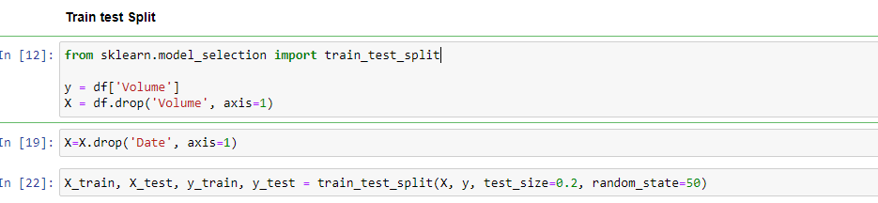

# Define the Random Forest Regression model and specify the hyperparameters

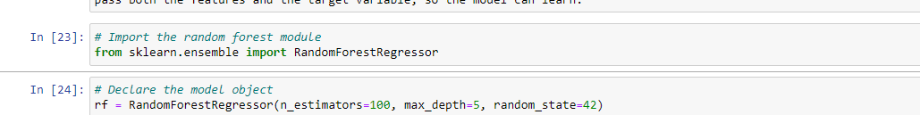

# Train the model on the training data



# Make predictions on the training set

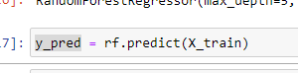

# Evaluate the model's performance on the training set

# Make predictions on the test set

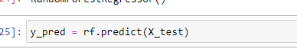

Evaluate the model's performance on the test set

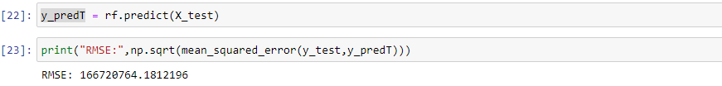

In this example, the scikit-learn `RandomForestRegressor` class is used to train the Random Forest Regression model. The hyperparameters are set as follows:

a. n_estimators: The number of decision trees in the ensemble. Here, we set it to 100.

b. max_depth`: The maximum depth of each decision tree. In this case, we set it to 5.

c. random_state: It is set to ensure reproducibility of results.

The dataset is split into training and test sets using `train_test_split()` from scikit-learn. The model is trained on the training set using the `fit()` method, and predictions are made on both the training and test sets using the `predict()` method. The performance of the model is evaluated using mean squared error (MSE) metric.

**4.4 HYPERPARAMETER TUNING AND OPTIMIZATION OF RANDOM FOREST REGRESSION MODEL**

Hyperparameter tuning and optimization for a Random Forest Regression model can be performed using scikit-learn, the required steps are listed below, the first 4 steps have been explained above :

#import the necessary libraries

from sklearn.model_selection import GridSearchCV, train_test_split

# Load your dataset and split it into input features (X) and target variable (y)

# Split the data into training and test sets

# Define the Random Forest Regression model

# Define the grid of hyperparameters to search

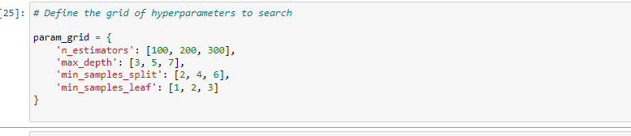

# Perform grid search cross-validation

grid_search = GridSearchCV(estimator=rf_model, param_grid=param_grid, cv=5, scoring='neg_mean_squared_error')

grid_search.fit(X_train, y_train)

# Get the best hyperparameters

best_params = grid_search.best_params_

print("Best Hyperparameters:", best_params)

# Train the model with the best hyperparameters on the full training set

best_rf_model = RandomForestRegressor(random_state=42, **best_params)

best_rf_model.fit(X_train, y_train)

# Make predictions on the test set using the best model

y_test_pred = best_rf_model.predict(X_test)

# Evaluate the model's performance on the test set

mse_test = mean_squared_error(y_test, y_test_pred)

print("Test Set Mean Squared Error:", mse_test)

```

In this example, we use the scikit-learn `GridSearchCV` class to perform grid search cross-validation. We define a grid of hyperparameters (`param_grid`) that we want to search over, including the number of estimators, maximum depth, minimum samples split, and minimum samples leaf. The `cv` parameter specifies the number of cross-validation folds to use, and `scoring` specifies the metric to optimize (negative mean squared error in this case).

The `GridSearchCV` object fits the model on different combinations of hyperparameters and performs cross-validation to evaluate their performance. After the search is complete, we retrieve the best hyperparameters using `best_params_` attribute. We then create a new Random Forest Regression model with the best hyperparameters and train it on the full training set.

Finally, we make predictions on the test set using the best model and evaluate its performance using mean squared error (MSE).

Remember to import the necessary libraries (`numpy`, `load_dataset()`, etc.) and adapt the code to your specific dataset and requirements.

4.5 COMPARISON OF PREDICTED VOLATILITY WITH ACTUAL MARKET CAPITALIZATION

When comparing the predicted volatility with the actual market capitalization specifically with respect to the Random Forest Regression model, it provides insights into the model's performance and its ability to accurately capture and predict market dynamics.

The predicted volatility from the Random Forest Regression model can serve as an estimation of expected market capitalization fluctuations. Comparing these predictions with the actual market capitalization values allows us to assess the model's accuracy and reliability.

By calculating evaluation metrics like mean squared error (MSE), root mean squared error (RMSE), or coefficient of determination (R-squared value), we can quantitatively evaluate the model's predictive performance. A lower error metric or a higher R-squared value indicates better prediction accuracy and a stronger correlation between the predicted and actual values.

Additionally, visualizing the predicted volatility alongside the observed market capitalization data can provide a comprehensive understanding of the model's ability to capture market trends and fluctuations. If the predicted volatility aligns closely with the actual market capitalization, it suggests that the model is effectively capturing the underlying dynamics and relationships.

However, significant discrepancies between the predicted and actual volatility may indicate areas for improvement in the model. These discrepancies could be caused by various factors such as changes in market conditions, unaccounted-for variables, or limitations in the model's architecture.

Continuously monitoring and evaluating the performance of the Random Forest Regression model as new data becomes available allows for iterative improvements and adjustments to enhance its accuracy and reliability over time. This iterative process helps refine the model's ability to predict volatility more effectively, providing valuable insights for risk management, financial decision-making, and investment strategies.

4.6 INTERPRETATION OF MODEL’S INSIGHTS AND PREDICTION

The interpretation of a Random Forest Regression model's insights and predictions involves extracting meaningful information about the factors driving cryptocurrency volatility and understanding the model's performance in predicting it.

Feature Importance: The model provides a measure of feature importance, indicating the variables that have the most significant impact on predicting volatility. By analyzing feature importance, we can identify the key drivers of volatility, such as market sentiment, trading volume, or macroeconomic indicators. This helps us understand which variables are most influential in determining cryptocurrency price fluctuations.

Direction of Effect: By examining the signs and magnitudes of the coefficients or feature importances, we can determine the direction of the effect each feature has on predicted volatility. Positive coefficients suggest a direct positive relationship, while negative coefficients indicate an inverse relationship. Understanding the direction of effect gives us insights into how specific factors impact cryptocurrency volatility.

Outliers and Anomalies: The Random Forest Regression model can identify potential outliers or anomalies in the data that may significantly influence predictions. These outliers could represent unusual market behavior, extreme events, or data errors. Investigating these outliers helps us gain insights into unique market conditions or anomalies that impact cryptocurrency volatility.

Visualization: By plotting the predicted volatility alongside the actual market capitalization, we can visually inspect how well the model captures the patterns and fluctuations in the data. This visualization helps us identify periods of high or low volatility, potential trends, and any discrepancies between the predicted and observed values.

Model Performance Evaluation: To evaluate the model's performance, we can use metrics like mean squared error (MSE), root mean squared error (RMSE), or coefficient of determination (R-squared). These metrics provide an overall assessment of how well the model predicts volatility compared to the actual market capitalization. Higher R-squared values or lower error metrics indicate better prediction performance.

Validation and Iteration: Continuously validating and iterating the model against new data helps assess its stability and generalization capability over time. By checking the model's performance on unseen data, we can determine if it maintains its accuracy and reliability. If necessary, adjustments and refinements can be made to improve the model's predictions.

Interpreting the model's insights and predictions empowers decision-making processes in areas such as risk management, portfolio optimization, and trading strategies. It helps market participants understand the drivers of cryptocurrency volatility and make more informed decisions based on the predictions provided by the model.apt